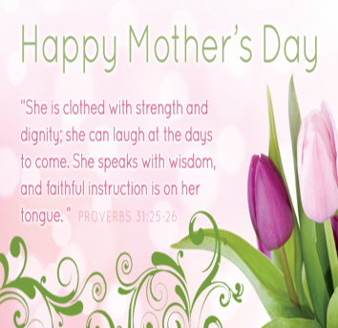****

**Always needed**

**New Handmade** SOCKS and UNDERWEAR Pillow Cases School Supplies Laundry Bags Dolls and Stuffed Animals Stockings Action Figures and Matchbox Cars Small toys for girls and boys Books & Coloring Books Pillows Fabric Backpacks

**Gently Used**  Small Luggage Drawstring Bags Blankets Clothing—all sizes and ages Duffle Bags Household Items  **Children’s Home Society items should be received by JULY 25th**

**PLEASE NOTE!**

Prayer Gatherings will no longer meet on Wednesdays!

**Please bring Desserts! Saturday, May 22nd** We will be providing extra desserts for the meal on Sunday May 23rd

**Next week! Graduation Sunday—May 16th**

We will recognize our High School and College Graduates!



 Meeting 3— 5:30

Making a special Mother’s Day gift to take home!

Next week—

**Battlearuim!**

Today Youth Mtg 3—5:30

Mon 1:00 pm Bible Study w/ Dana Wed 5:00 pm No Prayer MtgThurs Women’s Circles 1:00 & 7:00 Ascension of the Lord

**Announcements for May 9, 2021**