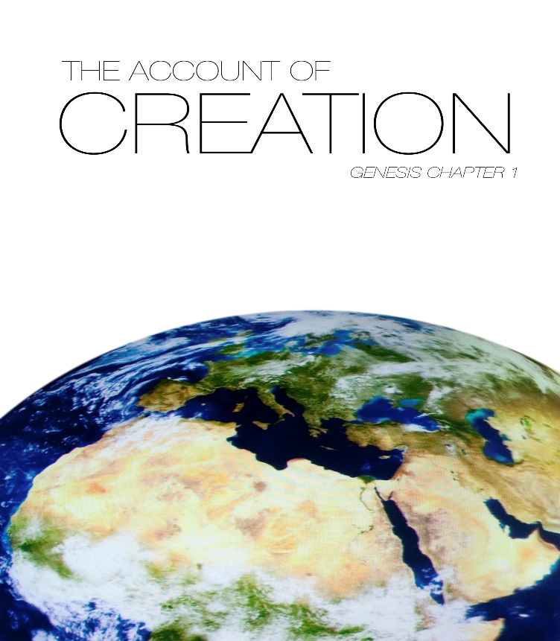

**HPC WORSHIP – 5-2-21**

*This Sunday we share together Holy Communion in our worship. If you are worshiping with us online, we encourage you to have some elements ready – bread, crackers, or other elements to use, along with a cup or cups of juice -- perhaps grape or cranberry -- or wine, with or without alcohol. Thank you for your preparation.*

* Those who wish are invited to stand

**ANNOUNCEMENTS**

**PRELUDE** “God of Wonders” *by Marc Byrd and Steve Hindalong*

Alanna Cushing *arranged by Alex Zsolt*

*Lord of all creation, of water, earth, and sky,*

*The heavens are your tabernacle.*

*Glory to the Lord on high.*

*God of wonders beyond our galaxy, you are holy, holy.*

*The universe declares your majesty, you are holy, holy.*

*Lord of heaven and earth.*

**CALL TO WORSHIP**

One: God, whose imagination saw all that is good, beautiful, and loving,

**All: continues to see us as beloved children in the divine family.**

One: The Word which called forth the stars in every universe,

**All: speaks to us of giving ourselves through the baptismal life.**

One: The Spirit, which moved over creation, breathing life into all things,

**All: fills us with peace and patience, with hope and healing to share.**

\***HYMN "I Sing the Mighty Power of God"** No. 32  vs. 1-2

1. I sing the mighty power of God

That made the mountains rise,

that spread the flowing seas abroad

and built the lofty skies.

I sing the wisdom that ordained the sun to rule the day;

The moon shines full at his command,

and all the stars obey.

1. I sing the goodness of the Lord who filled the earth with food;

God formed the creatures through the Word,

and then pronounced them good.

Lord, how thy wonders are displayed,

Wher-e’er I turn my eye,

if I survey the ground I tread

or gaze upon the sky!

**CALL TO CONFESSION**

One: We know too well our foolishness, our brokenness, our human ways of doing things. But God knows our hearts, our hopes, our desire to be made new. As we offer our prayers of confession, let us open ourselves to God, who will forgive us and give us new life.

**PRAYER OF CONFESSION**

**All: We have been created for goodness by you, Artist of all things, but we continue to be filled with bitterness. Your Word would enable us to speak of joy to others, but we offer only judgment. The Spirit which breathes hope into us could be shared with everyone we meet, but we are tempted to hold our breath until we turn blue, rather than giving peace to those around us. But you have said that everything created is good, even we foolish children of yours, God of wonder and grace. With the Spirit as our sister, we know we can bring healing and hope to those who need it most. With your Word, Jesus Christ, as our brother, we know we can tell others of your mercy and of our love for them in every moment.** *(Continue in silent, personal confession).*

**ASSURANCE OF PARDON**

One: By God’s grace, our chaotic choices become creative grace for others; our foolishness can be transformed by God’s goodness; our lives can become new by the Spirit of our God.

The good news is as true as it was on creation’s first morning: Creator God is the redeeming Word who is the Breath of life for all people, even us. Thanks be to God for forgiveness and grace in our lives. Amen.

**PASSING THE PEACE**

**ANTHEM "None Like You"** Craig Courtney

**STORY FROM SCRIPTURE: "God Makes a World"**  from The Family Story Bible

**SERMON – "Creation Imagination" Rev. Dr. Dana Sutton**

**THE LORD'S SUPPER**

**Invitation**

**Communion Prayer**

One: God is with you.

**All: God is with all creation.**

One: Lift up your hearts!

**All: We lift our hearts to God.**

One: Let us give thanks to God: Creator of all that is, Christ that calls us to wholeness, Spirit that blows us where it will.

**All: Thank you, God!**

One: We thank you, God—for everything. A long time ago, you decided to start something new. Out of that newness came all that exists. Out of that newness came the stars in the sky, the planets, and moons. The water, the air—and life!

**All: Thank you, God!**

One: Here, in this place, on this planet, you created life that took many shapes. Single-celled creatures that became many–celled creatures. Many-celled creatures that became plants, became animals, became us.

**All: Thank you, God!**

One: Throughout our history, we human beings have tried to understand how we came to be, and why we came to be – and how to be in relationship with all creation – and with each other. Throughout our history, we human beings have tried to understand how all things came to be, and why we came to be, and how to be in relationship with you. Sometimes, we’ve not done a good job of listening. Sometimes, we’ve not done a good job of loving. Sometimes, we’ve not done a good job of being in relationship with you, with what you have created, or with each other.

**All: We are sorry, God. We ask for your forgiveness. We ask for your help. Open our ears, our eyes, our hearts, and our minds so that we might listen to your call, so that we might listen to the needs of what you have created, so that we might speak those needs and live your love.**

One: When our ancestors made mistakes, you sent them guides to help them on their way – priests and prophets, teachers and healers, grandmas and grandpas, who called people back to your love. And in Jesus the Christ you were with us to teach us, to love us, to save us from ourselves.

Thank you, God!

**All: Thank you, loving God!**

One: Jesus laughed with those who laughed, and cried with those who cried. He learned what it meant to be part of your creation and tried to teach us with stories of seeds and sowers, of bushes and birds; in his love, he called us back into relationship with you. And so we pray the words he gave to all of his disciples, the ones that remind us that you love us with all the love a mother can give, with all the love a father can give, saying:

**All: Our Father, who art…**

One: On the night that Jesus was taken away, by people afraid of what he was teaching of your love, he gathered with his friends. He took a loaf of bread and gave thanks to you, saying, “Blessed are you, Lord God of the Universe, who brings forth grain from the earth.”

**All: Blessed are you, Lord God of the Universe; everything you have created is blessed.**

One: He took the bread, broke it, and gave it to his disciples saying, “Take this, all of you, and eat it. This is my body, given for you. Each time you eat it…remember me.”

**All: Blessed are you, Lord God of the Universe; everything you have created is blessed.**

One: He took a cup full of wine and gave thanks to you, saying, “Blessed are you, Lord God of the Universe, who brings forth fruit from the vine.”

**All: Blessed are you, Lord God of the Universe; everything you have created is blessed.**

One: He took the cup and gave it to his disciples saying, “Take this, all of you, and drink it. This is my blood. My forever promise to you and to everyone. Each time you drink, remember me.”

**All: Blessed are you, Lord God of the Universe; everything you have created is blessed.**

One: Blessed are you, God most holy. We ask that you would send your Spirit upon this bread and this cup that they, and we, might be the body of Christ—hope in the world, speaking, acting, and living the change that brings healing and wholeness. In this hope, your people praise you:

**All: Holy God! Holy One! Holy Three! Praise now and forever! Amen. Amen! AMEN!**

**Sharing of Gifts**

**Prayer after Communion**

**All: This bread we have eaten comes from the earth. The wine we have tasted comes from the soil. Thank you, God, for sharing it all. Help us to lend our voice in caring for Earth. Help us to see the birds of the air, the fish of the water, the plants and animals that live with us as part of our communion in your love. In Christ’s name, we ask it. Amen.**

**\* HYMN "God, Who Stretched the Spangled Heavens"**  No. 24  vs. 1 & 4

1. God, who stretched the spangled heavens,

Infinite in time and place,

Flung the suns in burning radiance

Through the silent fields of space;

We, your children in your likeness

Share inventive pow’rs with you.

Great creator still creating,

show us what we yet may do.

1. As each far horizon beckons,

may it challenge us anew,

children of creative purpose,

serving others, honoring you.

May our dreams prove rich with promise,

Each endeavor well begun.

Great Creator, give us guidance

Till our goals and yours are one.

**BENEDICTION**

One: And now, may the peace of creation’s Imagination, the peace of grace’s Word,

the peace of hope’s Spirit, and the deep, deep peace of God in Community, Holy in One, be with you this day and for always. Amen.



**Items still needed**

**New Handmade** SOCKS and UNDERWEAR Pillow Cases School Supplies Laundry Bags Dolls and Stuffed Animals Stockings Action Figures and Matchbox Cars Small toys for girls and boys Books & Coloring Books **Gently Used**  Pillows Fabric Backpacks Small Luggage Drawstring Bags Blankets Clothing—all sizes and ages Duffle Bags Household Items

**Announcements**

For more information on these, or any of the ongoing Mission projects, please see the May newsletter or contact Nancy Estler or Ann Shurman.

Graduation Sunday—May 16th

We will recognize our High School and College Graduates! Please help us send them off with love from their HPC Family by using the cards/boxes in the foyer.





Today No Youth Mtg Mon 1:00 pm Bible Study w/ Dana

Wed 5:00 pm Zoom Prayer MtgThurs National Day of Prayer

***Mother’s Day Diaper Drive until May 9th*** Donations of diapers can be left in the foyer or at the office. Checks should be made out to Diaper Drop Charities. Contact Pam Curtis for more information.

**Please bring Desserts! Saturday, May 22nd** We will be providing extra desserts for the meal on Sunday May 23rd

Women’s Groups currently meet the 2nd Thursday of each month at 1:00 & 7:00 pm

Zoom Prayer Meeting

Wed 5:00 pm

There will be no Youth Meetings tonight—Sarah is at Bluestone for the Spring Retreat.

Mon 1:00 pm Bible Study w/ Dana “Back to the Beginning—Stories of Genesis”